1. **Introduction**

In solid rocket motors, solid propellant is stored in the metal casing known as combustion chamber. Igniter is used for the initiation of the combustion of the solid propellant. During the combustion of the solid propellant, high pressure and temperature gases are produced and expand through the nozzle to produce thrust. The solid propellant regresses along the local normal to the burning surface during the combustion. The rate of this regression is typically measured in mm per second or inches per second and is known as regression rate (or burn rate). The burn rate of the solid propellant depends on the various operating conditions as well as formulations. Knowing quantitatively the burning rate of a propellant, and how it changes under various conditions, is of fundamental importance in the successful design of a solid rocket motor. In rocket propellant burning rate is influenced by certain factors, the most significant being the combustion chamber pressure and initial temperature of the propellant grain. The usual representation of the pressure dependence on burn rate is Saint Robert's Law.

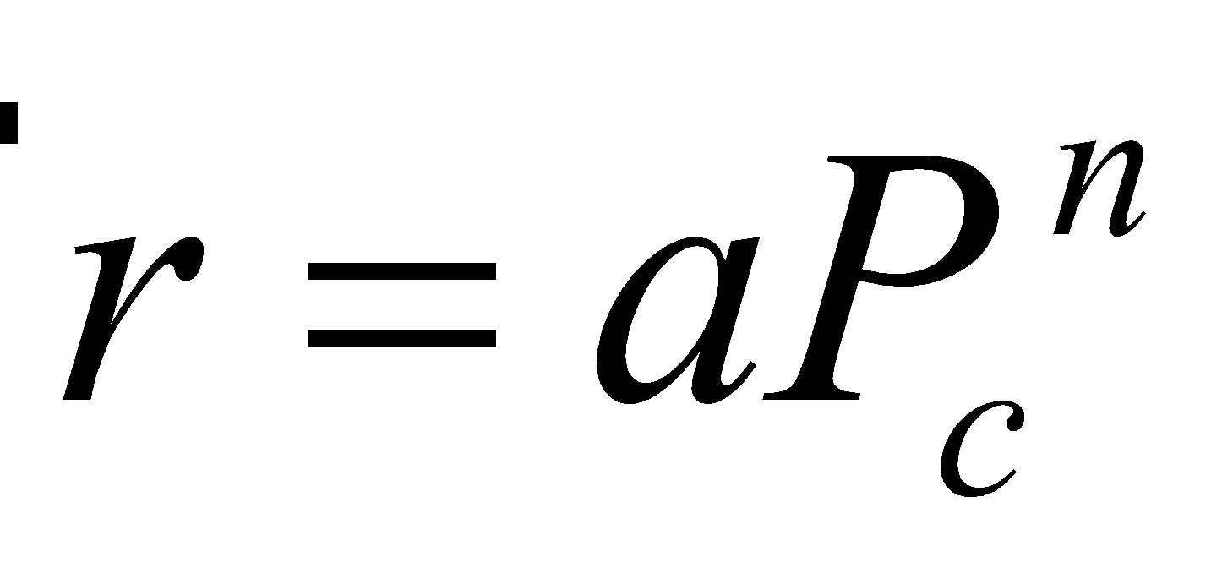

Where *ṙ* is the burn rate, *a* is the burn rate at unit pressure and *n* is the burn rate pressure index. The values of *a* and *n* are determined empirically for a particular propellant formulation. A Strand Burner (Crawford Bomb) or Ballistic Evaluation Motor (BEM) is commonly used to determine the burning rate of the solid propellants under various conditions. The burn rate pressure index is the slope of a straight line on a log-log plot of pressure vs burn rate.

1. **Experiments**
   1. **Experimental setup**

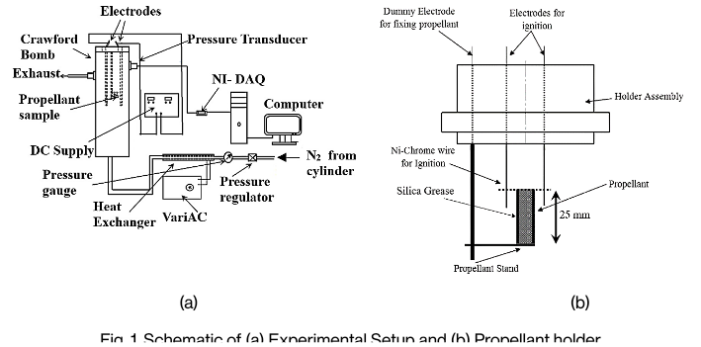

A standard Crawford bomb in conjunction with a pressure transducer was used to obtain the burning rates of propellants as shown in Fig. 1(a). The free volume of the Crawford bomb is 9.6 x 10-4 *m*3, which is more than 2000 times larger than the volume of the propellant sample used in the experiments. The propellant sample was placed on a propellant holder as shown in Fig. 1(b). The propellant holder houses two electrodes to facilitate ignition of the sample. The electrodes were connected to a D.C. power supply through a switch. An electric current of 22 V and 1 A was applied for ignition. The diameter of the Ni-Chrome wire used for ignition was 0.5 mm.

A piezo-electric pressure transducer (PCB-11B322) has been used to obtain the pressure variation during the experiment. The pressure variation inside the chamber was measured using the pressure transducer and plotted on a P-t graph as shown in Fig. 2. The pressure inside the Crawford bomb drops after the complete burning of the propellant sample. This was because, the piezo-electric pressure transducer measures only the change in pressure inside the Crawford bomb. The exhaust valve and inlet valve were slightly kept open to maintain constant pressure with a small flow of nitrogen inside the Crawford bomb when the propellant was not burning. However, as the propellant starts to burn, the pressure inside the Crawford bomb increases due to rapid mass addition in the gas phase. Further, when the propellant was completely consumed the pressure in the Crawford bomb starts to decrease and reaches the set constant value at which the experiments were being carried out. The Fig. 2 shown in this study is for the maximum pressure rise inside the Crawford bomb for the highest burn rates encountered. But the pressure rise for all other experiments was around 1 atm gauge pressure. The burn time was recorded as the time taken between the start and the end of burning as indicated in Fig. 2 as τb. Since a known length of propellant sample is used and the corresponding τb is obtained the resulting burn rate is calculated. A pressure regulator was positioned as shown in Fig. 1(a) to maintain the pressure within the bomb at a desired value. A commercially available nitrogen cylinder was connected to the supply line and was used to pressurize the bomb.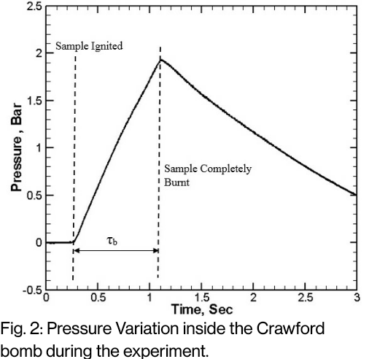

* 1. **Experimental Procedure**

The sample was placed in the propellant holder and the connections for ignition were completed. The non-burning surfaces were coated with silica grease to prevent non-uniform burning as shown in Fig. 1(b). The Crawford bomb was then filled with nitrogen gas, from a nitrogen cylinder, to the desired pressure using the pressure regulator. The pressure-time trace obtained from the pressure transducer output was used to calculate the time of combustion as described earlier. Knowing the length of the sample, the average burn rate is calculated as length over time of combustion. Experiments were repeated at each pressure to establish repeatability of burning rate values. The values reported are average values of these readings.

1. **Results**

| **Exp. No.** | **Length** | **Time** | **Burn Rate** |
| --- | --- | --- | --- |
| 1 |  |  |  |
| 2 |  |  |  |
| 3 |  |  |  |
| 4 |  |  |  |
|  |  |  |  |
|  |  |  |  |
|  |  |  |  |
|  |  |  |  |

1. **Conclusions**